4.1 Maclaurin and Taylor Polynomials

Chapter 3 was concerned with the development of ideas surrounding the convergence or divergence of various different kinds of series. In what way is this knowledge relevant? How can it be used to provide meaningful real world results?

Recall (Local Linear Approximations):
For some functions it may be simple to evaluate but difficult to compute values of f near a.
Instead we will use the equation of the tangent line at to estimate f near a.

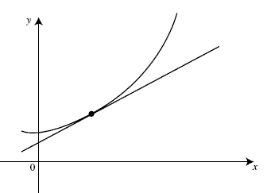
$$\left(a,f\left(a\right)\right)$$
$$y=p\left(x\right)$$
$$y=f\left(x\right)$$

Example 1: Find the local linear approximation of at .

Note (again): only approximates well when values close to 0.
approximates poorly when values are far from 0.

The question we would like to ask is if there is any way to improve our ability to approximate values of .

Local Quadratic Approximations:

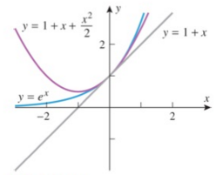

Example 2: Find the local quadratic approximation of at .

Question: How might we be able to obtain a way to approximate values of even further from ?

Our new problem: What does the formula look like for a local approximation with a polynomial of degree n?

Definition:

Example 3: Find the Maclaurin polynomials , , , and for .

Note: Not all approximating polynomials need to be approximating a curve at .
We can consider approximating a curve at an arbitrary .

Definition:

Example 4: Find the first four Taylor polynomial for about .

Example 5:
Determine the nth Taylor polynomial for about and express it in sigma notation.

Example 6: Find the nth Maclaurin polynomials for …

Example 7 (you try):
Determine the nth Taylor polynomial for…
- about and express it in sigma notation.
- about and express it in sigma notation.

